BOOKS
6 | 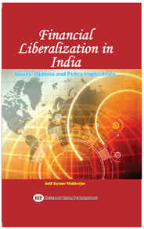 | Salil Mukherjee | Financial Liberalization in India: Issues, Options and Policy Implications | New Delhi, Research India Publications. 2010. ISBN 9788190436243
7 |  | Debasish Pradhan  &  Tridib Tripathi | Public Libraries : Information Marketing and Promotion | Kolkata: Levant Books. 2010. ISBN 978-9380663111
8 | 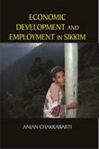 | Anjan Chakrabarti | Economic Development and Employment in Sikkim | New Delhi: Authorspress. 2009. ISBN 978-8172735012
9 | 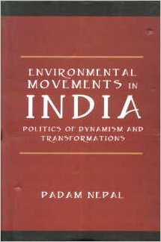 | Padam Nepal | Environmental Movements in India:  Politics of Dynamism and Transformations | New Delhi: Authorspress. 2009. ISBN 978-8172734909
10 | 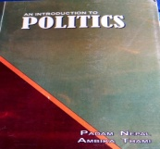 | Padam Nepal  &  Ambika Thami | An Introduction to Politics | Darjeeling: Bimaleswari Publications. 2009. ISBN 978-81-9096-850-8
11 | 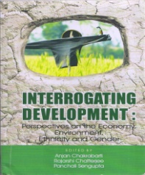 | Anjan Chakrabarti,  P. Sengupta & R.Chatterjee | Interrogating Development:Perspectives on the Economy,Environment,Ethnicity and Gender | Setu Publication for St. Joseph’s College,Darjeeling.  ISBN:978-93-80677-94-1
SOCIAL SCIENCES

