BOOKS
SOCIAL SCIENCES

SL. NO. | BOOK COVER | AUTHORS | BOOK TITLE | PUBLISHER
1. | 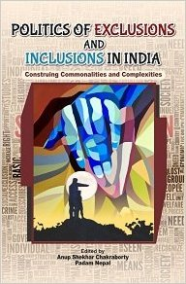 | Anup Shekhar Chakraborty and  Padam Nepal | Politics of Exclusion and Inclusion in India: Construing Complexities and Commonalities | New Delhi: Authorspress. 2016. ISBN 978-9352071524
2. | 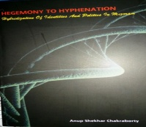 | Anup Shekhar Chakraborty | Hegemony to Hyphenation: Hybridization of identity and Politics in Mizoram | Darjeeling: St. Joseph’s College Publications. 2015. ISBN 978-81-909690-3-1
3. | 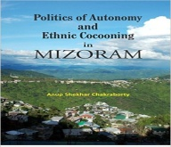 | Anup Shekhar Chakraborty | Politics of Autonomy & Ethnic Cocooning in Mizoram | New Delhi: Authorspress. 2015. ISBN 978-8172737412
4 | 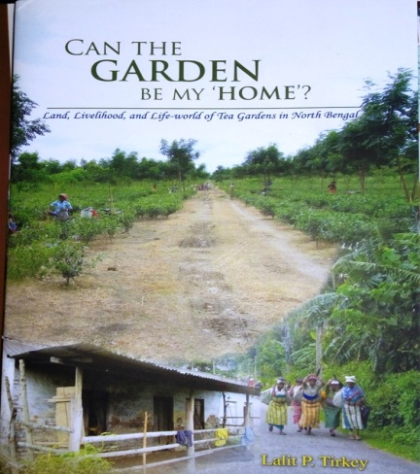 | Lalit P Tirkey | Can the Garden be My Home? Land, Livelihood and Life-World of Tea Gardens in North Bengal | Darjeeling: St. Joseph’s College Publications. 2015. ISBN 978-81-909690-4-8
5 |  | Padam Nepal  &  Anup Shekhar Chakraborty | Politics of Culture, Identity and Protest in Northeast India (Two Volume Set). | New Delhi: Authorspress. 2012. ISBN 978-8172736262

